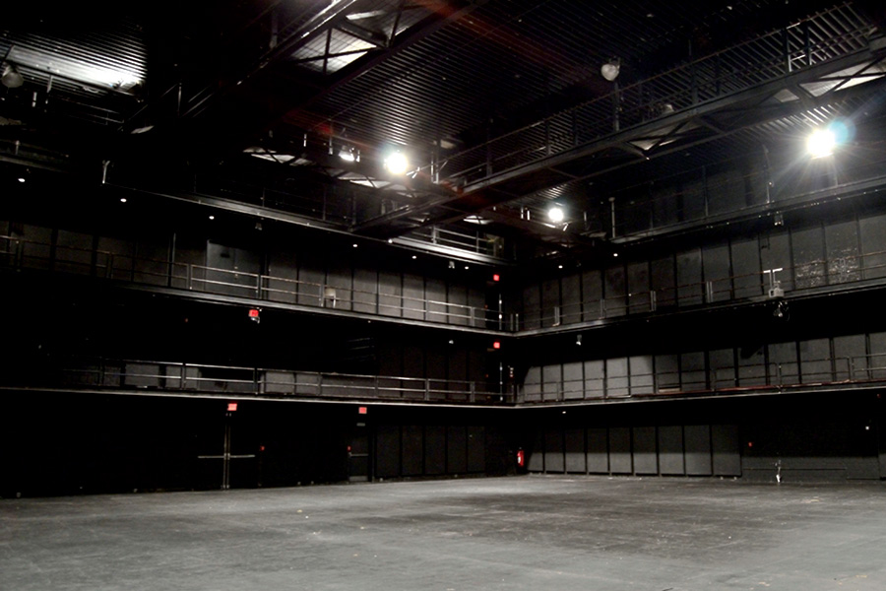
The Performing Arts Center, SUNY Purchase

The Repertory Theater
Technical Packet

The Performing Arts Center is a full service performance facility. The Center maintains a central inventory of equipment for most theatrical and concert needs. Due to the nature of the facility as a four theater complex we do not publish inventory lists. To ensure that the needs of your production are met we request that you communicate your requirements to us as soon as possible, so that we can make the appropriate allocations. You will find, listed by department, the general types of equipment that we carry. For further information please feel free to contact the Production Office.

Vectorworks, AutoCAD, and PDF files of the theater’s ground plan are available by request.

For further inquiries about space or equipment availability, please contact the Production Office at (914) 251-6266 or megan.corkrum@purchase.edu.

The Performing Arts Center's address is

Mailing:
Performing Arts Center,
Purchase College State University of New York
ATTN: Production Office
735 Anderson Hill Rd.
Purchase, NY 10577

For visiting wireless access:
Login: PurchaseGuest

Password: Please ask Production staff

REPERTORY THEATER STAGING:

Loading Dock Access:

The Repertory Theater has NO loading dock. Equipment enters the space through standard double doors and onto an elevator via The Performing Arts Center underpass. Underpass clearance is 11’. Temporary parking is permitted for loading and unloading only. Short term and overnight parking for trucks is available by prior arrangement in Parking Lot West 2.

Stage Lift:

The Repertory Theater features a 20' x 40' stage lift which drops 21’-10 ½” to the trap room below. It also rises 3' above floor level to create a raised platform. For loading in/out and adjusting set levels, the lift operates independently, and MUST REMAIN STATIONARY DURING REHEARSALS AND PERFORMANCES

Seating Capacity:

House seating varies by design of staging configuration. Depending upon layout, seating capacity can accommodate up to approximately 400 seats. Prior arrangements must be made with production office to insure we can meet your seating needs.

Rigging:

As a flexible space the Repertory Theater contains no counterweight sets. However it has a dead hung grid with the ability to put spot lines, chain hoists or rig hemp linesets over most of the performance space. This theater also features 3 moveable catwalk pairs in 3 rows, to aid in rigging and lighting hangs. The performing arts center does maintain a small stock of rigging gear and rope, discuss your exact rigging needs with the production office prior to load-in.

Labor:

The stagehands at the Performing Arts Center are professional, freelance, union stagehands and wardrobe personnel. We abide by many standard union labor rules. For shows traveling with a “Yellow-Card" we are under the jurisdiction of the New York City and Westchester IATSE Local 1. If you are unfamiliar with the area please contact the Production Office and we will help you arrange your labor through the local Business Office.

General Equipment:

Each theater is equipped with a variety of A-frame ladders. A personnel lift may be made available with prior arrangement.

The Performing Arts Center owns concert chairs, bass stools, music stands and stand lights for orchestra use. There are 4' x 8' risers available in heights of 8", 16", and 24". The PAC does not own choral risers.

The PERFORMING ARTS CENTER also maintains an assortment of concert quality Steinway pianos which are available by prior arrangement. Please be advised that The PERFORMING ARTS CENTER DOES NOT ALLOW TAPE OR ADHESIVES OF ANY KIND ON ANY OF THE PIANOS. THERE ARE NO EXCEPTIONS TO THIS POLICY AND WILL BE STRICLTLY ENFORCED.

The PERFORMING ARTS CENTER has a Steinway trained house piano tuner, contact the Production Office in advance to arrange tunings, standbys and to discuss associated fees.

The Performing Arts Center also maintains a lecture package including a lectern, chairs, and tables; available through prior request.

Dressing Rooms:
Dressing rooms for this theater are located one floor below stage level, and accessible via stairs stage right and freight elevator near the lobby. There are 4 Chorus rooms to accommodate 12 people each. All have makeup mirrors and lights, with tables and chairs. There are restroom facilities and showers located in each dressing room.

Laundry:
There are laundry facilities located in an adjacent section of the building which must be reserved for use in advance of load-in. We can supply washing, drying and ironing facilities. Portable steamers, irons and ironing boards are available with prior arrangement.

Special Effects:
Any special or pyrotechnic effects must be approved by the production office prior to load in. All necessary and appropriate certificates must be presented upon arrival.

Wireless Coverage

There is Wi-Fi available on the stage, dressing rooms, and the lobby.

For visiting wireless access:
Log in: Purchase Guest
Password: Please ask Production staff
Theater Dimensions

Width Depth Height

Overall 82'-8" 82'-8" 36'0"
25.19m 25.19m 10.97m

Open space 71'-7 1/2" 71'-7 1/2" 27'-3"
21.83m 21.83m 8.30m

Lift 40'-0" 21'-10 1/2" 3' Max. Above stage
12.19m 6.66m 0.91m

Gallery Width 5'6" 8'-1"
1.67m 2.46m

Grid (clearance above) 2'0" (.61m)
Grid (from deck) 33'11" (10.34m)

Catwalks (from deck) 27'3" (8.31m)
1st Gallery 9'5 1/2" (2.88m)
2nd Gallery 18'9" (5.71m)

Loading Elevator 8'-0" 8'-9" 7'-10"
2.44m 2.67m 2.39m

Repertory Theater Soft Good Inventory:

The theater does NOT have a soft good inventory for this space.

The Repertory Theater Lighting and Electrical Information:

Control:

The Repertory Theater is equipped with an ETC Ion 1000 with 2x10 Fader Wing. An ETC Net3 RVI with 2 flat screen monitors available. The control booth is located on the South Wall of the First Gallery level.

The Repertory Theater is equipped with a Lighting Control Network. Using ACN and sACN protocol for control of Dimmers and DMX Out ports. Ethernet Ports are located in the Lighting Booth and Dimmer room.

DMX In and DMX Out ports are available for any touring consoles which may need to access the house system. They are located as follows:

Lighting booth – 1st Gallery South wall
North and South walls – Stage level
North and South walls – 1st Gallery
North and South walls – 2nd Gallery

There are two DMX In ports located at each position, allowing control of the house system (DMX addresses 1-384) and 640 additional DMX addresses.

House Lights:

There are scoop lights hung overhead for general worklight and illumination, affixed to the grid, permitting the moving catwalks to move freely. House lights are dimmable from the control booth and stage level doors or via DMX/sACN available throughout the theater.

Company Power:

In addition, there are three 400 amp/three phase, 208v company switches available in the dimmer room. These four disconnects draw from the same power that feeds the theater’s dimming system. The combined load on the company switches plus the house system cannot exceed 1200 amps/phase. These disconnects are equipped with cam-lock connectors which are NOT ground & neutral reversed.

House Dimmers and Circuitry:

The Repertory Theater is equipped with a dimmer-per-circuit ETC Sensor dimming system. There are 356 20A dimmers and 22 50A dimmers dispersed throughout the theater

Additional Lighting Inventory:
The Performing Arts Center maintains a large inventory of ETC, Altman and other various instruments which is available to the user. Rental charges may apply. Due to the constant rotation of our inventory among our four theaters, we do not list fixtures quantities. Below is a list of a selection of fixture types in the PAC Inventory. For further information please contact the Production Department (914) 251-6266
Focusing Units | Frame Size
ETC Source Four 5º @575w | 14"x14"
ETC Source Four 10º @575w | 12"x12"
ETC Source Four 19º @575w | 6.25"x6.25"
ETC Source Four 26º @575w | 6.25"x6.25"
ETC Source Four 36º @575w | 6.25"x6.25"
ETC Source Four 50º @575w | 6.25"x6.25"
Wash Units | Frames Size
PAR 64, 1Kw | 10"x10"
ETC S4 PAR, 750w | 7.5"x7.5"
8" Fresnel, 1Kw | 10"x10"
6" Fresnel, 750w | 7.5"x7.5"
3" Fresnel, 300w | 3.75"x3.75"
Mini-ten, 1Kw | 8.75"x5.5"
14" Scoop, T-3, 1Kw | 14"x14"
Birdie, 150w | 2.75"x2.75"
GAM Stick-up, 150w | N.F.
CYC and Border Lights | Frames Size
FAR-CYC, T-3, 4 CKT, 4 light, 1K per CKT, Top/Bottom | 15"x18"
ALT T-3, 3 CKT, 6 light, 1K per CKT (Length 4'6") | 8.5"x12.75"
KLG T-3, 3 CKT, 9 light, 1K per CKT (Length 6'-9") | 8.5"x8.5"
KLG T-3, 4 CKT, 8 light, 1K per CKT (Length 6') | 8.5"x8.5"
KLG T-3 4 CKT 12 light, 1.5K per CKT (length 8') | 7.25"x7.75"

Audio:

Auditorium Amplification:

The Repertory Theater is a black box space and, as such, has no permanent speaker system. Speakers are made available to be placed according to the configuration and needs of each event.

House Console

The house console is a Yamaha LS9-32 digital mixing console. In addition to the console, the house system is also equipped with two Denon DN-C630 CD players. The house mixing console, and associated equipment, are located in the audio booth in the center of the south wall on the first gallery level. . This theater is also equipped with a computer dedicated to audio with a variety of software including Show Cue System, Stage Research SFX, Yamaha Studio Editor, Shure wireless workbench, Wavelab 7, Reaper, Dante Virtual Soundcard, etc. All software and firmware is kept to the most current version.

Audio Input

Forty eight microphone lines run from the audio booth to locations throughout all levels of the theater, including the trap room. There are six audio tie lines running from the theater’s patch bay to a central patch point for the facility that can be used to cross-connect audio from various spaces within the facility.

House Amplification

Although the theater has no permanent speakers, it is equipped with four 100 watt per channel Yamaha P2100 stereo amplifiers that may be patched into any of the theater's thirty six speaker lines, located throughout the catwalk, main, and trap room levels of the theater.

Communication:

The theater is equipped with a single channel Clear-Com system which is accessible from virtually all points within the theater. There is no paging system installed from the theatre to the dressing rooms.

Additional Audio Equipment:

The Performing Arts Center maintains an extensive inventory of playback machines, microphones, speakers, amplifiers, signal processing equipment, additional intercom equipment, cables, and accessories. Additional equipment is available to events on an as-needed basis. Due to the nature of the Performing Arts Center as a multiple venue complex, frequently serving numerous simultaneous users, it is not possible for us to maintain a published listing of currently available equipment. Please feel free to call the Production Office and speak with either the Director of Production or Audio Supervisor regarding the specific needs of your production.

Performing Arts Center Contact List:

Megan Corkrum (914) 251-6266

Director of Production megan.corkrum@Purchase.edu

Peter Specce, (914) 251-6221

Asst. Director of Production Peter.Specce@Purchase.edu

Justin Herminghouse (914) 251-6240

Production Technolgy Manager Justin.Herminghouse@Purchase.edu

Bennett Marrow (914) 251-6219

Production Coordinator Bennett.Marrow@Purchase.edu

Rental Book Manager (914) 251-6232

Box Office – Sales/Ticket Purchases (914) 251-6200

Box Office – Manager (914) 251-6212

Performing Arts Center Website: www.artscenter.org

Site contains venue information and e-mail links to most of the center's staff.

DINING

On-Campus Dining hours will change during school breaks

Hours Subject to Change (and quite often do change, especially around holidays) without notice.

Campus Center North/ The Hub Starbucks

On Purchase campus On Purchase Campus

Mon – Fri 7:30am – 12:00am Located in Fort Awesome

Sat – 10:00am – 1:00am On Lincoln Ave

Sun – 10:00am- 12:00am (914) 251-6988

Mon-Fri 7:30am-11pm

Sat&Sun 10am-11pm

Enstein Bagels

On Purchase campus

Located

Mon – Fri 7:30am – 3:00pm

Sat & Sun – Closed

Directions to Purchase College, SUNY Performing Arts Center:

Location Access via:
Parking Lot West 1 | Underpass in between  Parking Lots West 1 and West 2 | Parking Lot West 2
- The Concert Hall “A” Loading Dock  - PepsiCo Theater “B” Loading Dock | - Main Lobby  - Box office  - Administrative offices  - ADA Elevator  - The Repertory Theater “D” *  Loading Area and Elevator | - Recital Hall “C” Loading Dock  - Paint Deck  (Concert Hall Alternate Loading Dock)  - ALL Overnight Parking  (With Prior Approval)
* The Repertory Theater (“D”) does not have a dedicated Loading Dock. Loading is done on street level in the underpass, which has direct access to the stage lift and freight elevator. The Repertory Theater Stage Lift runs from the street level to stage level.

By Car:

From New York City, Southern Westchester, and Long Island:
Take the Hutchinson River Parkway, north to Exit 28, Lincoln Avenue. Turn left onto Lincoln Avenue and proceed approximately one mile to Anderson Hill Road (2nd traffic light). Turn right onto Anderson Hill Road. The campus is immediately on the left.

From Rockland County and Northern New Jersey (via the Tappan Zee Bridge):
Take I-287 (Cross Westchester Expressway) to exit 8E. Shortly after first traffic light, bear left onto Anderson Hill Road. Proceed approximately 2.5 miles. The campus is on the left, just after intersection at Lincoln Avenue.

From Northern Westchester:
Take I-684 south to Exit 2 (Route 120), drive over the bridge and turn right onto Route 120 South (Purchase Street). Follow Route 120 south, 3.2 miles to Anderson Hill Road (1st traffic light) and turn left. Take Anderson Hill Road to 2nd traffic light. The campus is on the left, just after intersection at Lincoln Avenue.

From Connecticut, via the Merritt Parkway (which becomes the Hutchinson River Parkway in New York State):
Proceed south to the New York Exit 28, Lincoln Avenue (Note: Do not get off at Exit 28 in Connecticut). Turn right onto Lincoln Avenue and proceed approximately one mile to Anderson Hill Road (2nd traffic light). Turn right onto Anderson Hill Road. The campus is on the left, just after intersection at Lincoln Avenue

From Connecticut, via I-95:
Take I-95 south then take I-287 West to Exit 9N (Hutchinson River Parkway). Take Hutchinson River Parkway North to Exit 28, Lincoln Avenue. Turn left onto Lincoln Avenue and proceed approximately one mile to Anderson Hill Road (2nd traffic light). Turn right onto Anderson Hill Road. The campus is immediately on the left.

By Train:

Metro North Schedule Information:
Phone: (800) METRO-INFO (212) 532-4900
www.mta.info/mnr

The White Plains train station maintains a more frequent schedule. Trains from White Plains and Port Chester both end up at Grand Central Station

The last train out of White Plains: 1:14 am (Weekdays and Weekends)
The last train out of Port Chester: 12:58 am (Weekdays and Weekends)

From New York City via rail from Grand Central Station, take the Harlem line/Metro North to White Plains. Board the Anderson Hill Road bus No. 12 or take a taxi to campus.

Alternatively, take the New Haven Line/Metro North to Port Chester and take a taxi to campus.

By Bus:

Bus/Westchester: (914) 682-2020

www.beelinebus.com

Take the No. 12 bus northbound from White Plains or southbound from Yorktown, Mount Kisco, or Armonk. Buses leave approximately once every hour during normal business hours on Weekdays and the schedule varies on weekends

